Great Yarmouth Local History & Archaeological Society

Founded 1888

Derek Leak
Honorary Treasurer.
190 Brasenose Avenue,
Gorleston-on-sea,
Great Yarmouth,
Norfolk. NR31 7EE Thursday, 14 August 2014

Thisis an edited version of the article by Derek Leak which will be reproduced in full in the Society’s 2014 Annual Journal – On sale January 2015

Excursion to Castle Acre and Sedgeford - August 2014

On Sunday 10th August 2014, 30 members of the Great Yarmouth Local History and Archaeological Society, with some friends, travelled to West Norfolk for the second excursion of 2014. This turned out to be fascinating, if a little on the damp side during part of the day. Ann Dunning had once more made excellent arrangements and organised everything - except the weather - to perfection.
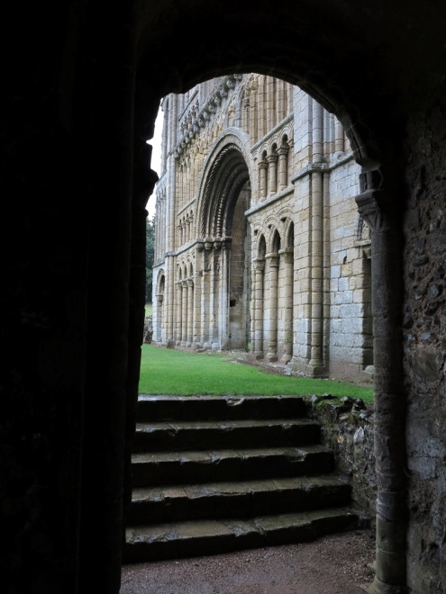

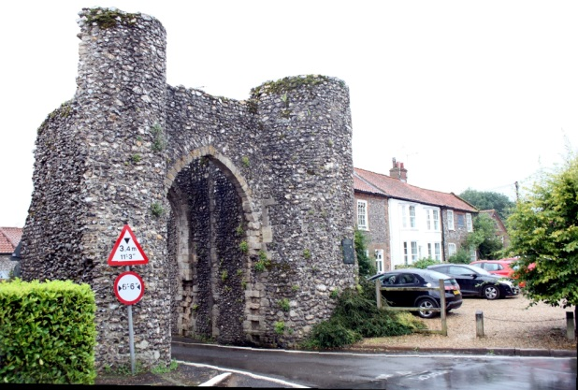

Gate into Castle Acre West Wall of Priory Church

We travelled first to the village of Castle Acre, which has the dual attractions of Castle and Priory.
Many of our party took advantage of the café on the Village Green during the period of heavy rain which accompanied our stay. The more hardy souls, missed out the tea and cakes and headed straight for the Priory. The view from a slight rise after exiting the visitor centre is breathtaking, with the west wall of the Priory Church prominent, faced with some superb Norman blind arcading. The Prior's lodging had been progressively improved and extended so that by 1500 that it was easy to understand why many thought the Church had become too rich and powerful. We visited the chapter house, dormitory, dining hall, lavatories, bakery and brewery and then took shelter in the English Heritage shop for a hot drink.

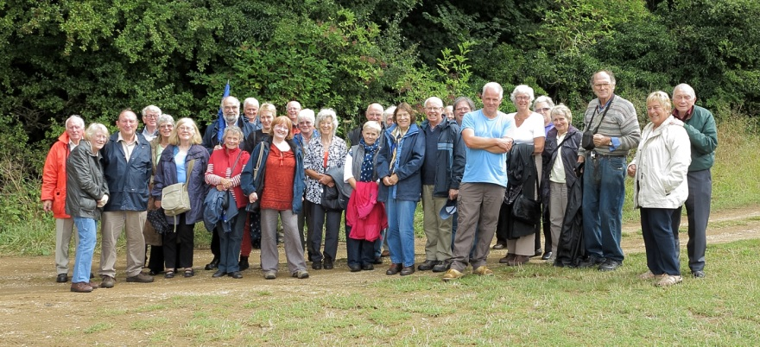

The GYLH&AS Party at Sedgeford

It took about an hour to travel to our second destination, Sedgeford. The origins of the project can be traced back to a hotel bar overlooking the Bay of Naples. It was here in 1995 that a chance meeting took place between SHARP's founder director, Dr Neil Faulkner and the owner of the Sedgeford Hall Estate, Professor Bernard Campbell. Agreement was reached and the excavations started in 1996. They have been carried out each summer for the past 19 years. In what is a unique enterprise in England, the same village has been excavated year after year to reveal past activity ranging over more than 4500 years of
history.
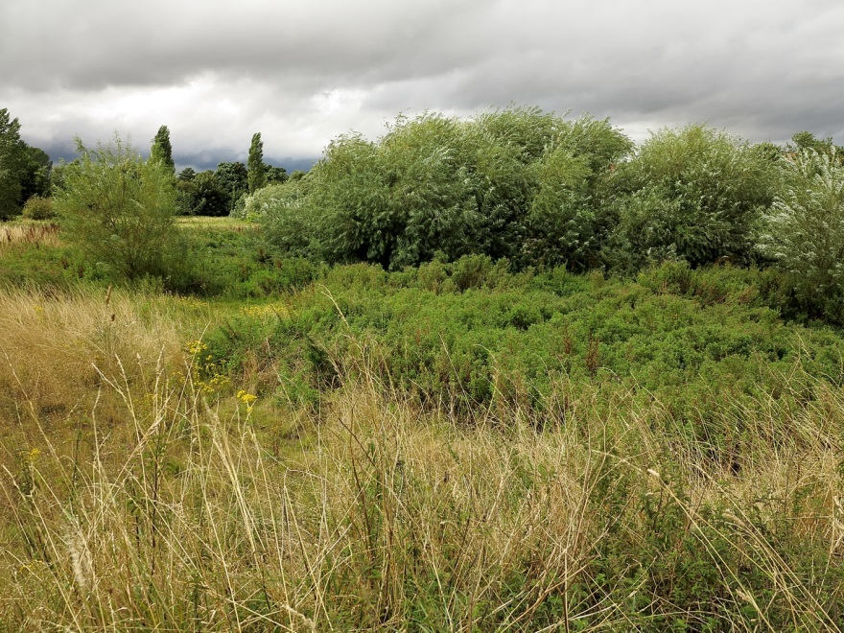

The site of the Anglo Saxon cemetery - known as "The Bone Yard"

Diverse and fascinating finds have included, an Iron Age Gold Torc found in two pieces in 1965 and 2004 and an Iron Age Horse Burial, which was found on the same day as a hoard of Iron Age gold Gallo-Belgic staters hidden in a cow bone. In 2006 a body was found from a Roman site, burnt in what appeared to be a fire pit for a grain drying oven. Several unusual aspects of the find led to it being described as "an unsolved murder" in the local and national press.

Dr John Jolleys was able to show us two Anglo Saxon grain drying or malting ovens recently found on the site. Both appeared to be of similar dates and were physicallyclose to one another. These are unique finds and seem to indicate technical progress being made in the village 1500 years ago.

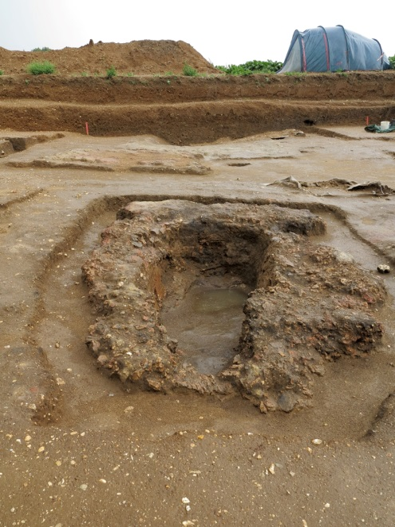
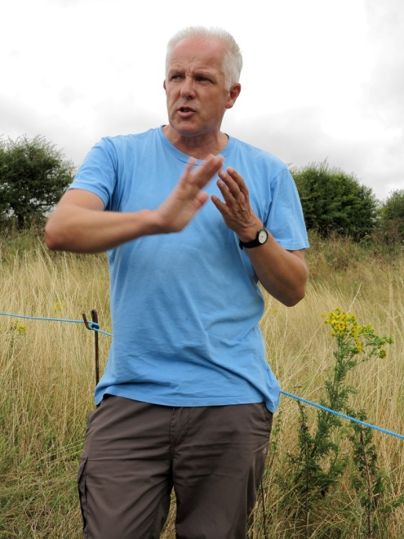

Gary Rossin Anglo Saxon Grain Drying Pit

Text: Derek Leak .
Photograph of Castle Acre Gateway: Michael Wadsworth.
Other Photographs: Derek Leak.

This is an edited version of the article by Derek Leak which will be reproduced in full in the Society’s 2014 Annual Journal – On sale January 2015

Registered Charity No 277272

